[Test Plan] Sauce Demo version 1.0

Document Status | [DRAFT]
Test Plan Creator | Andiko
Test Plan Reviewer | - M Ridhwan K  - Reviewer_2  - Reviewer_3

Introduction

Overview Feature to be tested
This Test Plan is designed to ensure that the Add User and Login functionalities work properly, securely, and meet user requirements. These features are critical as they handle user access and authentication within the system.

Goals and Objective
This phase of the project will deliver the Add User and Login functionalities, which enable user creation and secure access to the system.The initial phase focuses on ensuring that core functionalities such as successful user registration, login with valid credentials, and rejection of invalid inputs are working as expected. Must-have functionality, particularly related to data validation.

Test Item
List of test items (feature / product)

No | Feature | Test Item
#1 | Login | - Login with valid credentials  - Login with invalid credentials  - Login with user doesn’t exist
#2 | Add User | - Add User using a valid format  - Add User using an invalid format  - Add User using an existing username

In Scope Testing
List of in feature to be tested

No | Feature | Requirement / Design specifications
#1 | Login | 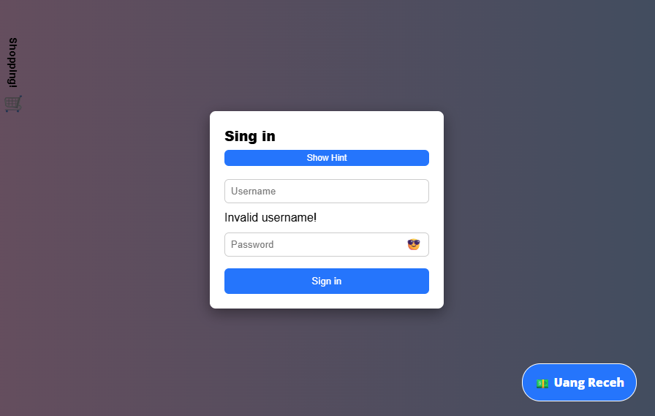
#2 | Add User | 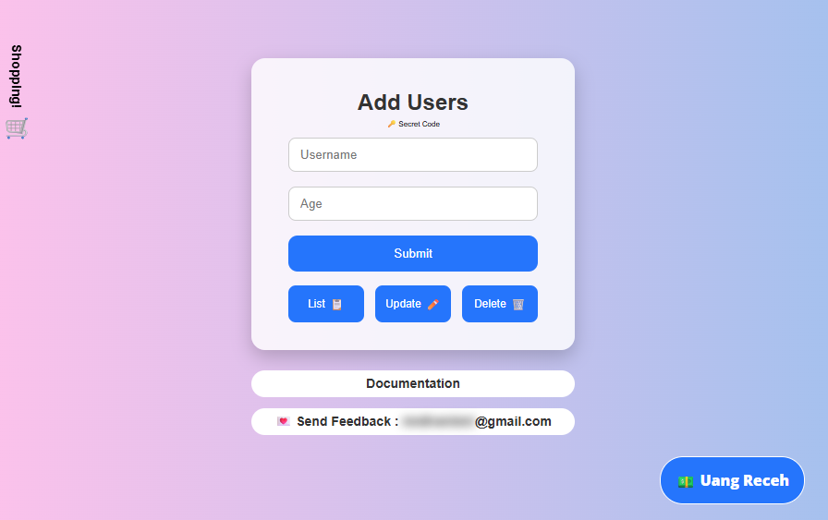

Out of Scope Testing
List the features of the software / product which will not be tested.

No | Feature | Reasons
#1 | Update User | This testing phase will be focus to add user feature
#2 | Delete User | This testing phase will be focus to add user feature
#3 | Shopping | This testing phase will only cover login and add user feature

Testing Approach
The project is using an agile approach, where testing is conducted in iterative cycles aligned with development sprints.

Manual testing will play a big role for this testing phase as it is a basic feature, Manual testing will have predefined test cases for both features which includes but not limited to Validate functionality, UI behavior, and error handling.

Exploratory testing will be used as a part of the testing as the team have to identify unexpected behaviors, usability issues, and edge cases that are outside the predefined steps set by the Manual testing.

Test Environment
Information about testing environment that will be used during testing phase e.g URL, and version of App
- Website: https://belajar-bareng.onrender.com/
- Env:Dev
- Browser: Edge, Chrome, Firefox

Test Deliverables
- Test Plan (this document itself): [Test Plan] Belajar Bareng
- Test Case: Test Plan and Bug Report Sesi 2
- Test Script (if any): -
- Test data (if any): -
- Defect Report: Test Plan and Bug Report Sesi 2
- Test Report: -

Testing Timeline

No | Task | Estimation Time |  | Actual Time
 |  | Start Date | Finish Date | Start Date | Finish Date
#1 | Develop Test Planning | 3 Apr 2026 | 4 Apr 20266 | 3 Apr 2026 | 4 Apr 20266
#2 | Develop Test Case | 5 Apr 2026 | 5 Apr 2026 | 5 Apr 2026 | 5 Apr 2026
#3 | Test Case Review | 6 Apr 2026 | 6 Apr 2026
#4 | Execute Test | 7 Apr 2026 | 8 Apr 2026
#5 | Retest Bug | 9 Apr 2026 | 10 Apr 2026

References
List of related documents e.g PRD, Figma design, API Contract, Copy document etc

API Contact: https://belajar-bareng.onrender.com/documentation
Design: Figma.com

